Chapter 4, Problem 65.

For the circuit shown in Fig. 4.131, determine the relationship between V_{o} and I_{o}.

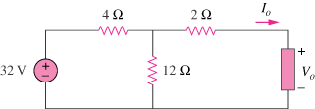

Figure 4.131
For Prob. 4.65.

